PLOT

Embark on a journey with the eccentric Yamada clan as they navigate through the amusing and heartwarming moments, vividly depicted in an exceptional comic strip format. Witness the shenanigans of Takashi Yamada and his idiosyncratic wife Matsuko, who struggles with domestic chores, as they overcome the highs and lows of career, matrimony, and parenthood. The household comprises a sharp-tongued grandmother, a son who yearns for hipper parents, a vocal daughter who defies her petite frame, and a troublesome dog with its own set of challenges.

Description

1. Family Comedy: "My Neighbors the Yamadas" is a heartwarming and humorous animated film by Studio Ghibli, showcasing the everyday adventures and quirky dynamics of the Yamada family through charming vignettes and watercolor-style animation.

2. Slice of Life: This Studio Ghibli gem offers a delightful peek into the life of an average Japanese family, blending whimsical storytelling with beautiful, hand-drawn visuals to highlight the small joys and challenges of family life.

3. Animated Anthology: "My Neighbors the Yamadas" presents a series of witty and touching sketches that explore the ups and downs of family relationships, brought to life by the unique artistry of Isao Takahata and Studio Ghibli.

Trailer of My Neighbors the Yamadas

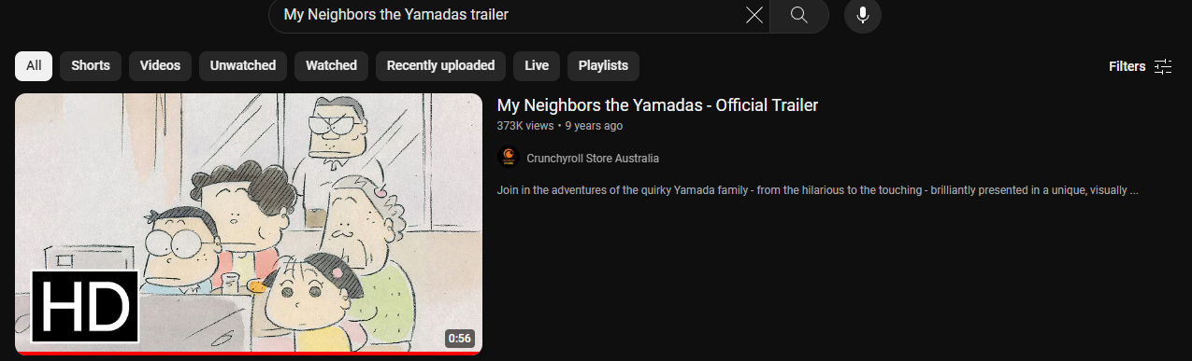

Clips of My Neighbors the Yamadas

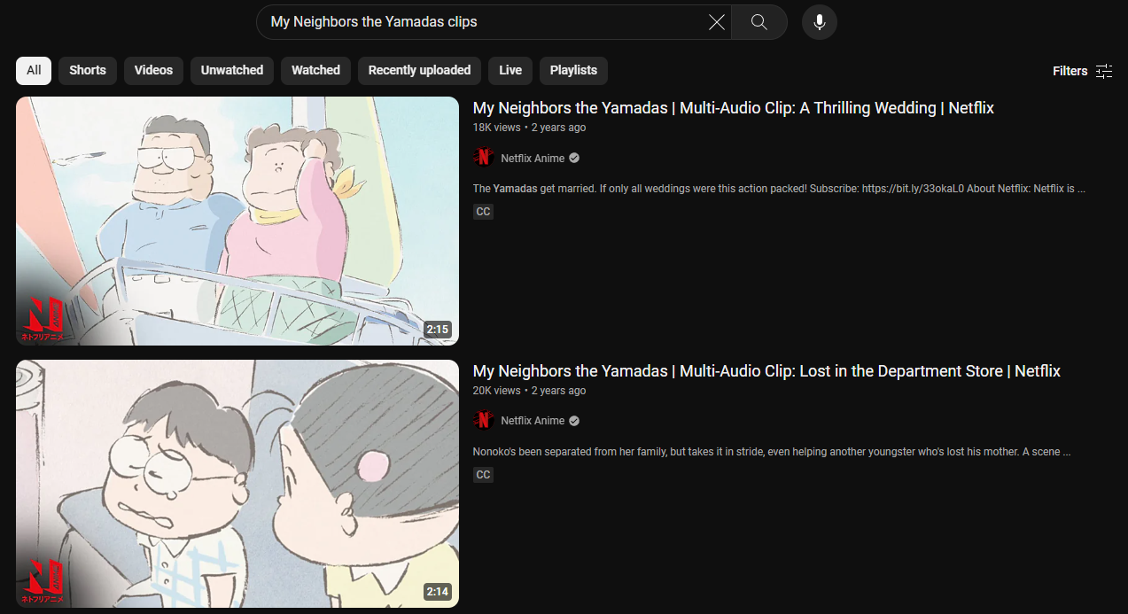

ChatGPT for Description

